CONTACTS -

Applications - Contacts.app
Select contacts to export - Command to select some, Shift to select a range, Command + A to select ALL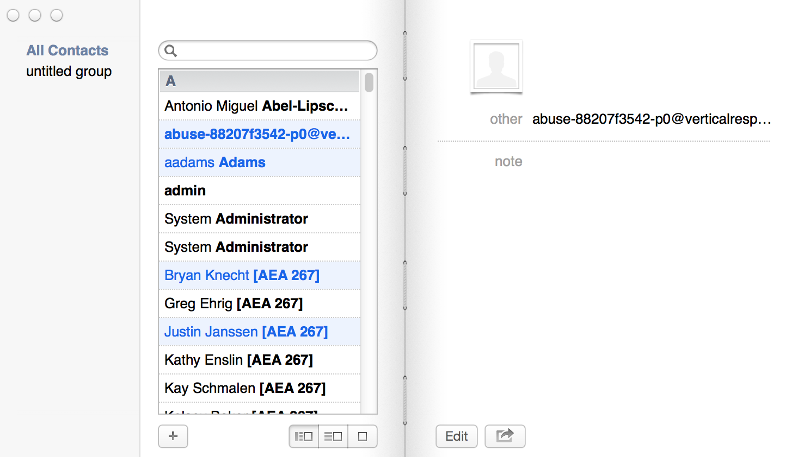
Go to File - Export - Export to vCard
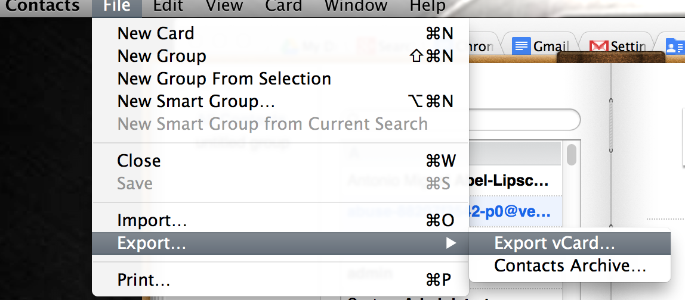

Make note of file name and location. Go to Contacts, 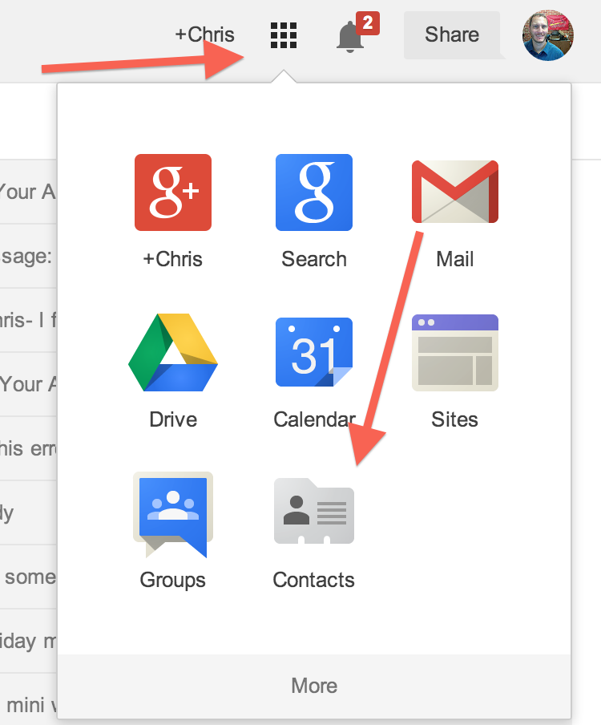

and on left hand side, Import Contacts.

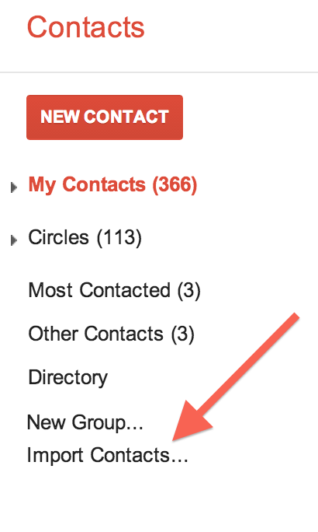

Choose your contacts file from before.
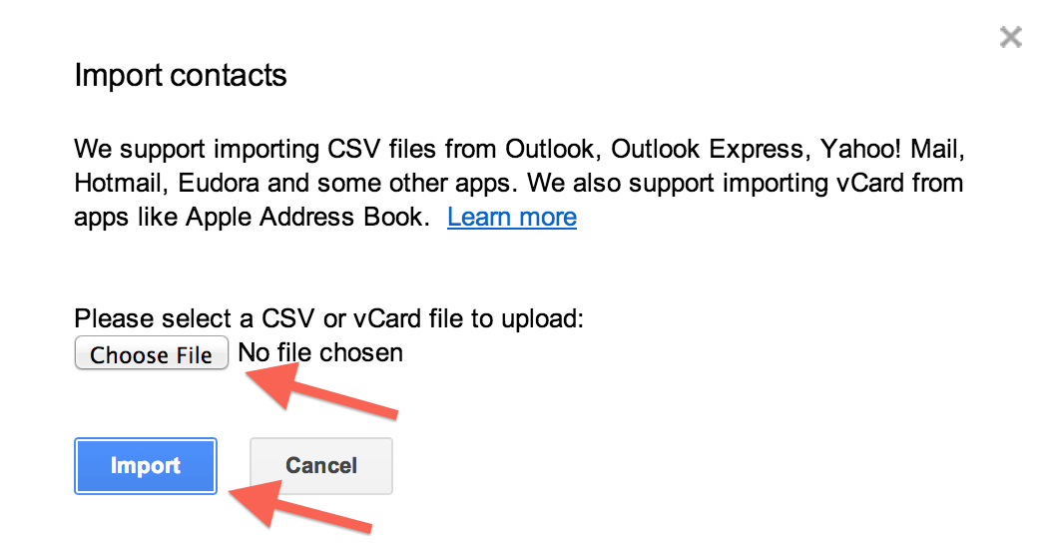

You can also browse the school directory….

