SETUP
Go to sent items in “old” email and copy one of your signatures.

Login to Google with Denver (@denver.k12.ia.us) account. To get to it…..
gmail.google.com

Go to Settings…..
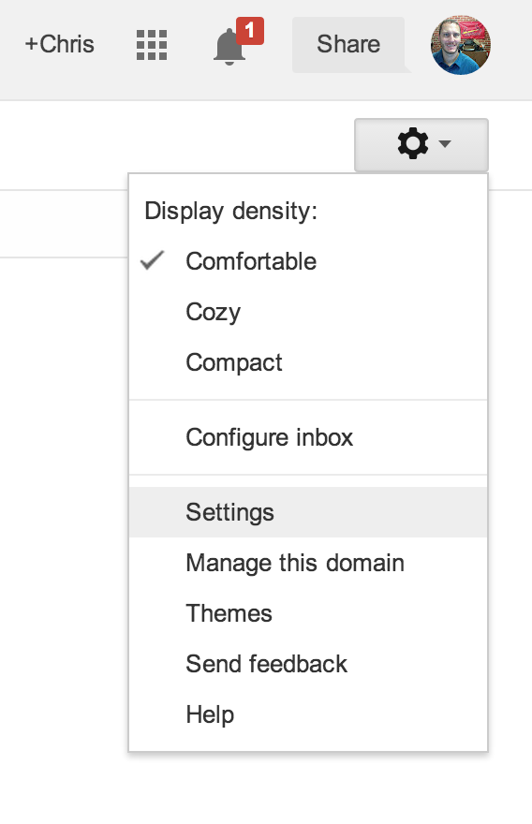
Settings - Signature - Copy from a sent email in “OLD” mail and paste in.
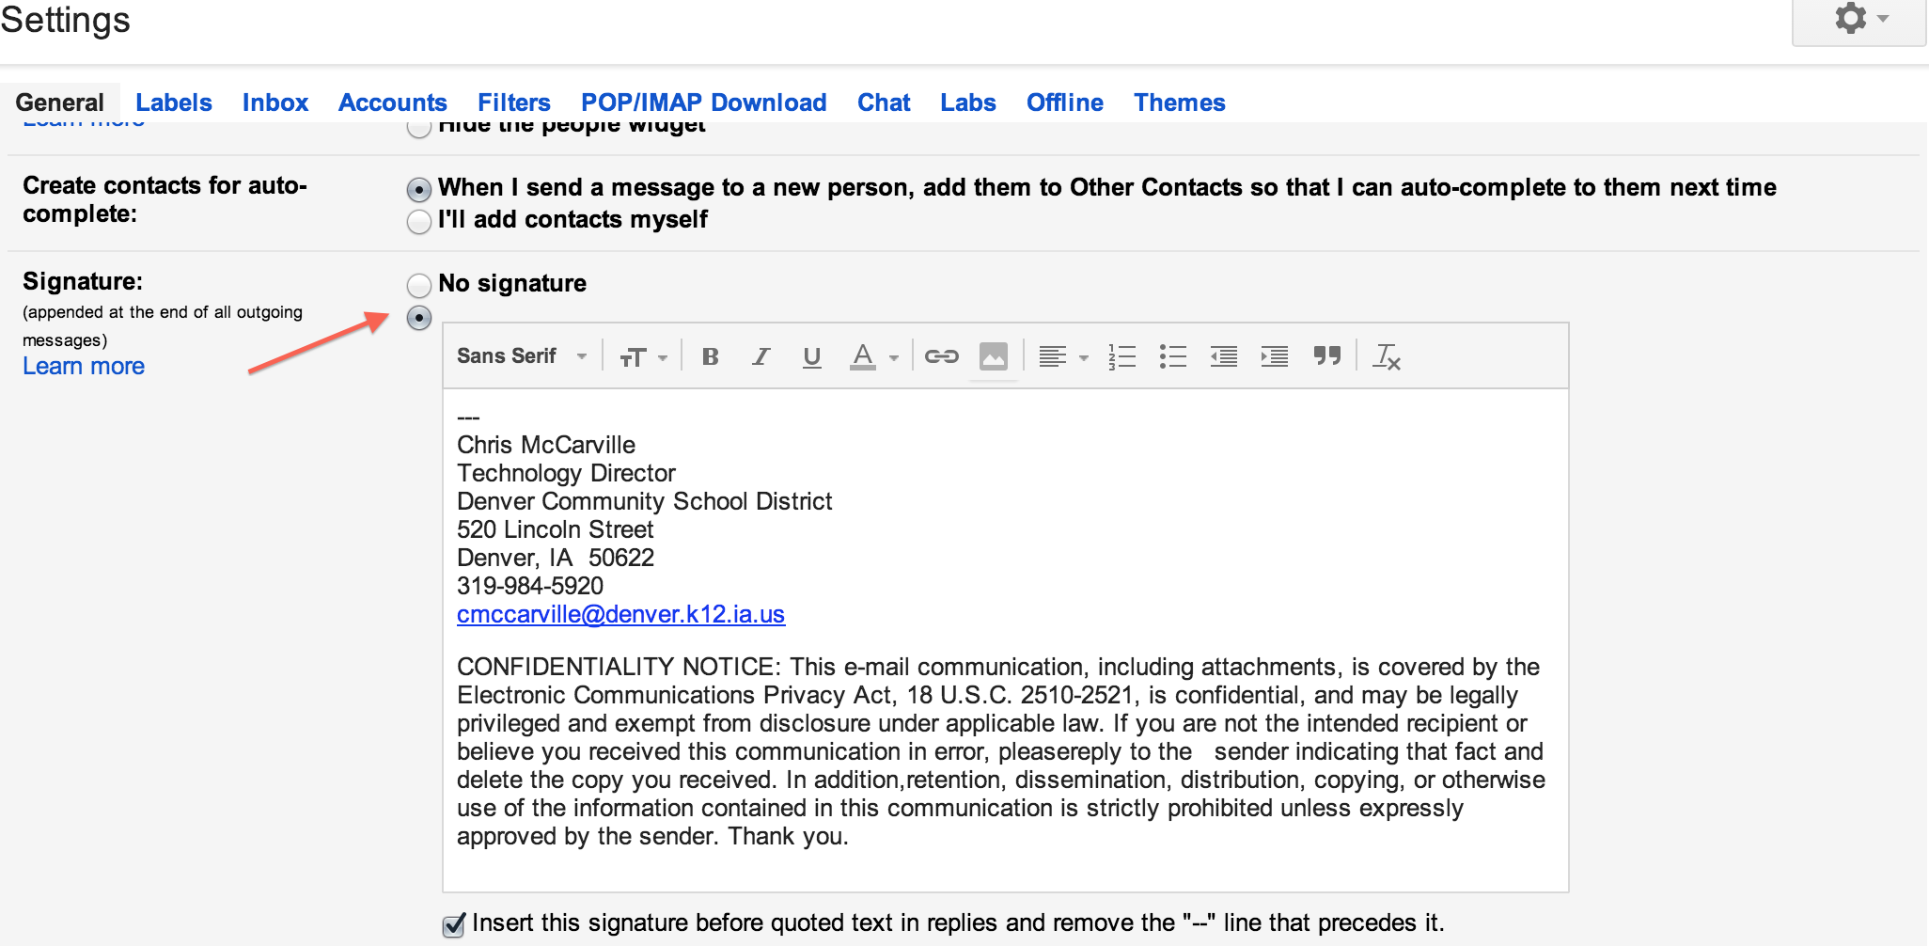
Settings - Pop/IMAP Downloads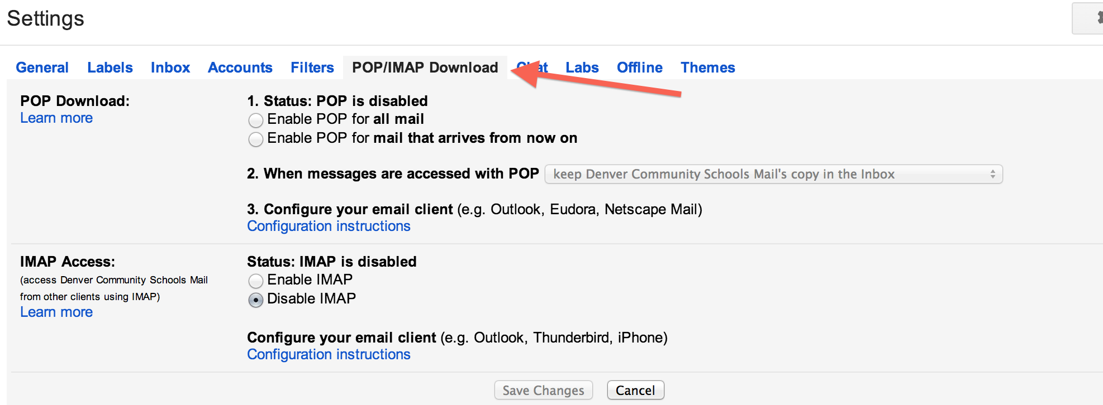
IMAP Access - ENABLE (This will be for the Mail.app and for phone use)
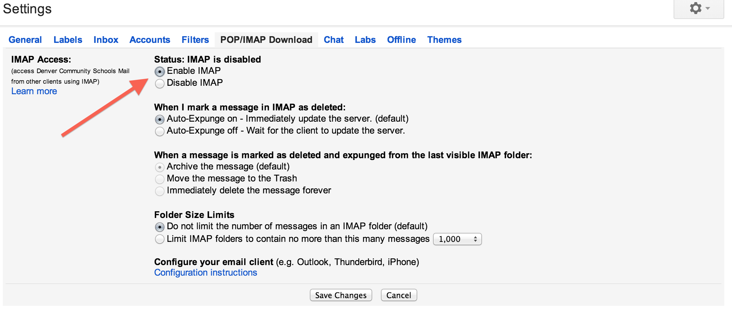
If you need to find instructions on getting your email setup on another machine or email client, look for this link…..
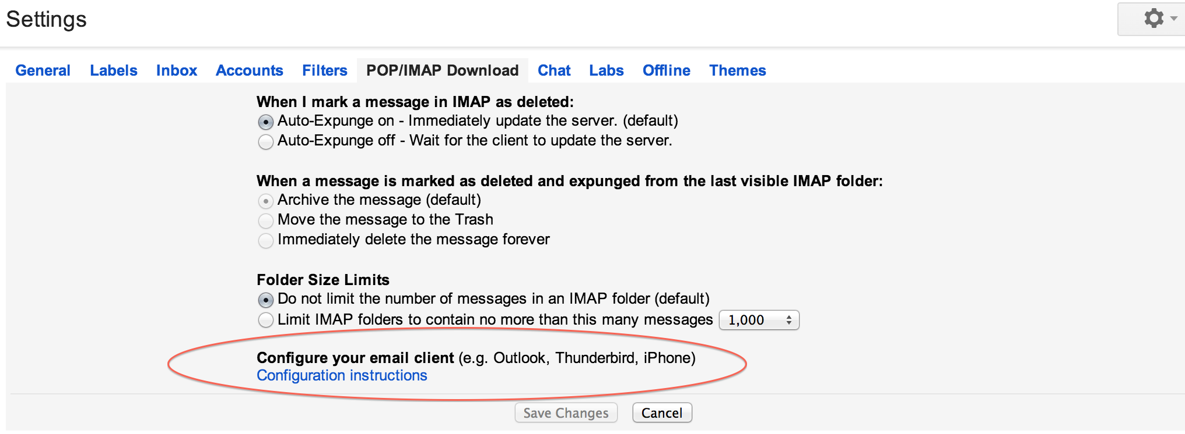

Mail app….
(If you see a prompt to add an account when you open Apple Mail, skip to step 5:)
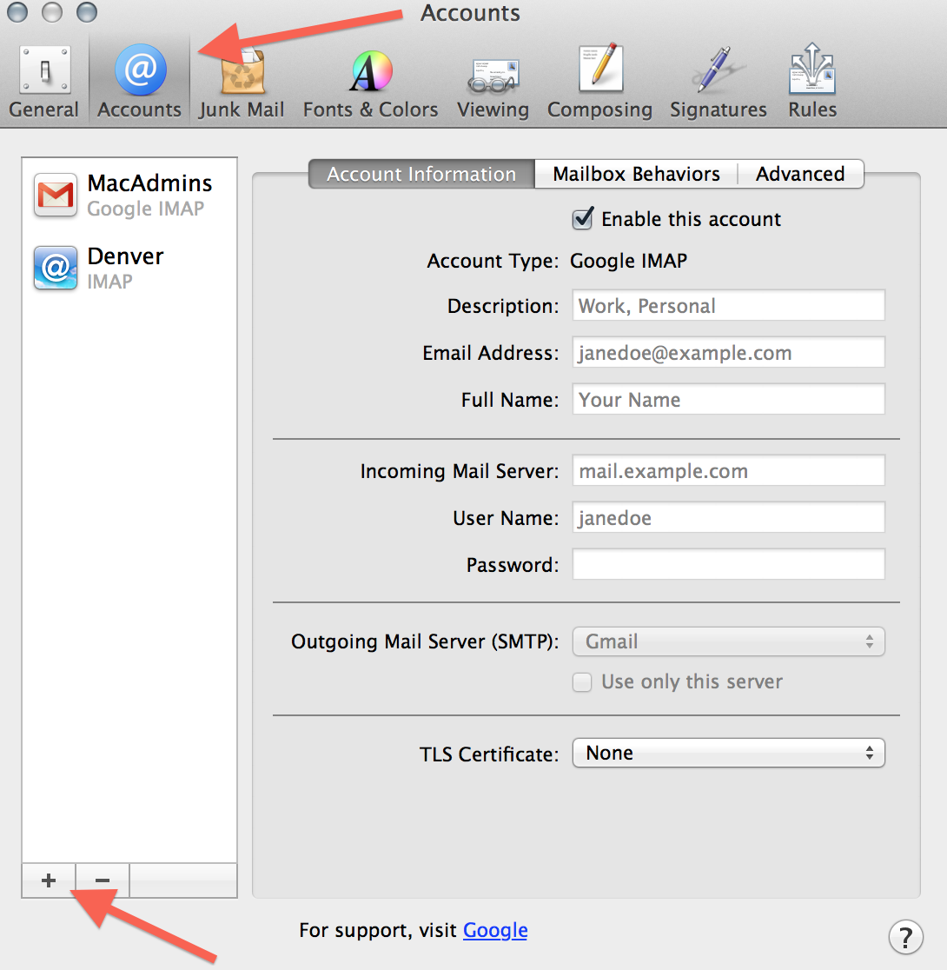
- Open the Mail app on your computer.
- Select the Mail menu at the top, and then Preferences.
- Open the Accounts section.
- Click the + button in the bottom corner.
- Choose Google.
- Type your name.
- Type your full email address
  - Students = FMLastname##@denver.k12.ia.us (## = Grad year)
  - Staff = FLastname@denver.k12.ia.us
- Type your password.
- Click Set up.
- Make sure Mail is selected and click Done.

- Incoming Mail (IMAP) Server - Requires SSL
  - imap.gmail.com
  - Port: 993
  - Requires SSL:Yes
- Outgoing Mail (SMTP) Server - Requires TLS

- smtp.gmail.com
- Port: 465 or 587
- Requires SSL: Yes
- Requires authentication: Yes
- Use same settings as incoming mail server

- Full Name or Display Name: [your name]
- Account Name or User Name: your FULL Gmail address (username@denver.k12.ia.us).
- Email address: your FULL Gmail address (username@denver.k12.ia.us)
- Password: your Google password

TIPS….
ARCHIVE, instead of Delete…..

Why archive, instead of Delete? https://support.google.com/mail/answer/6576?hl=en&ctx=mail
- Clean up your inbox by getting messages out of your way.
- Archived messages stay in your account in case you need to find a phone number in someone’s signature or you become famous and write a memoir.
- When you delete a message (instead of archiving), it will be automatically and permanently deleted after about 30 days.

Distribution Groups -
All (staff / students / everybody), All staff, high school, middle school, elem,
Will be tweaked as needed. Not all students will be able to post to all lists. Will adjust as we go along and as needed.

Old email will still be “available” until summer. Watch from what account you are “Sending” from. If it will not go out, it you may be using the old server.

To “COPY” your old folders (MAILBOXES) to new Gmail,
within the MAIL.APP, click and drag…..all there is to it.

CONTACTS -

Applications - Contacts.app
Select contacts to export - Command to select some, Shift to select a range, Command + A to select ALL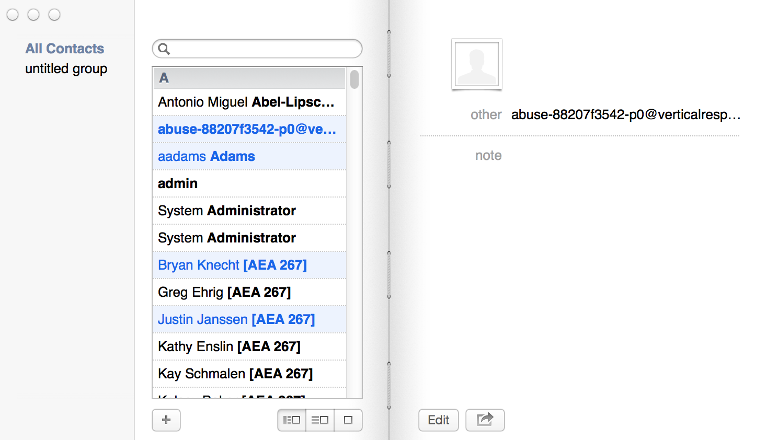
Go to File - Export - Export to vCard
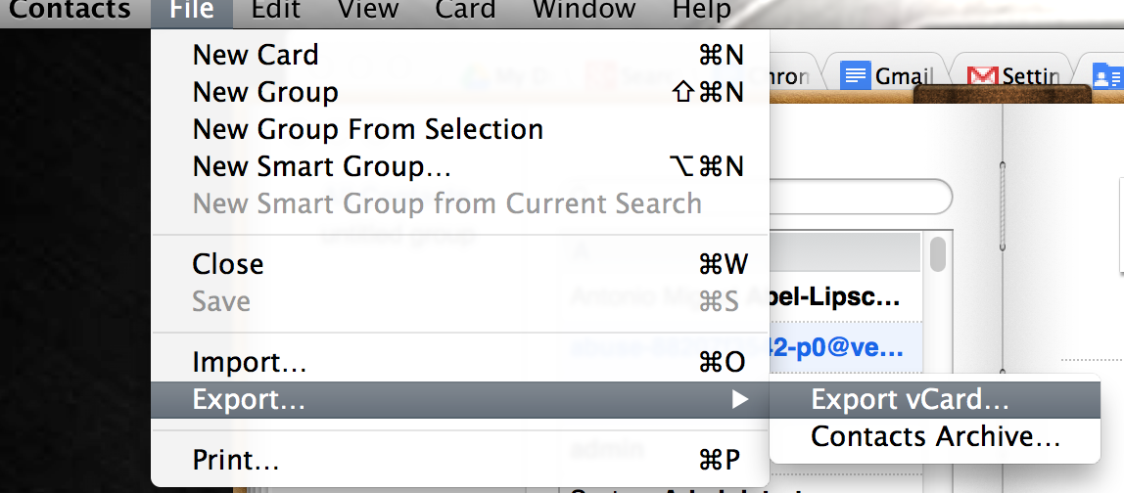

Make note of file name and location. Go to Contacts, 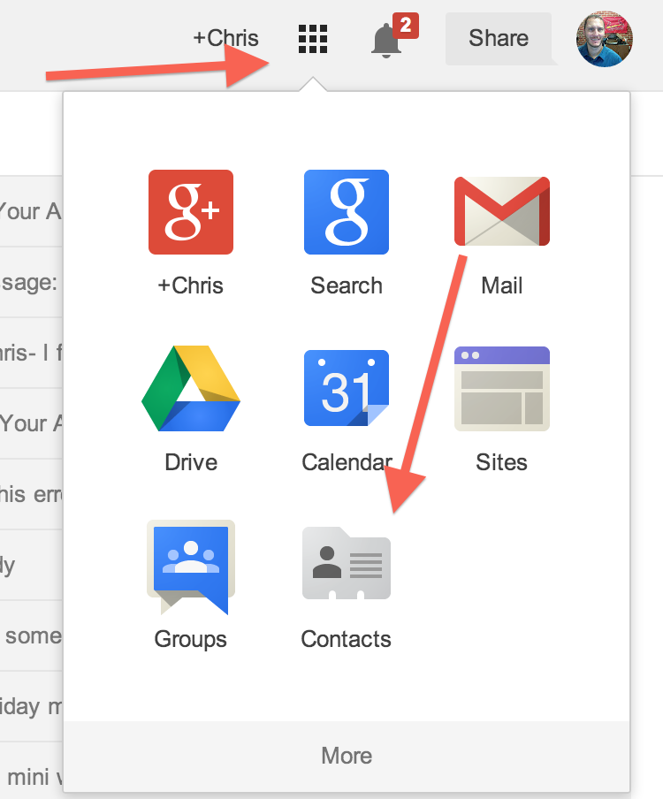

and on left hand side, Import Contacts.

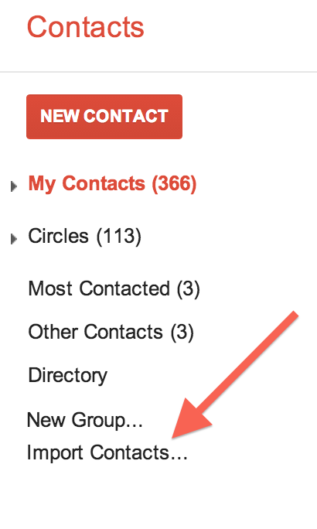

Choose your contacts file from before.
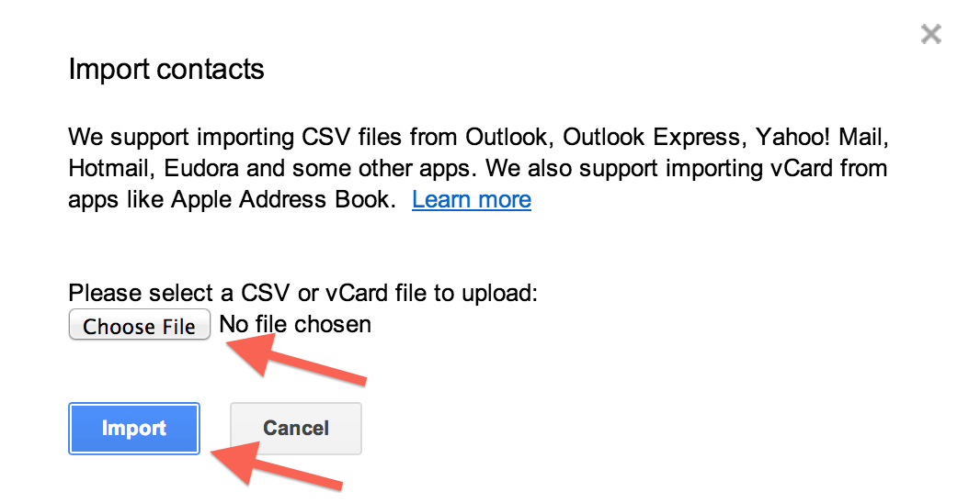

You can also browse the school directory….

