Follow these steps carefully to set-up your GMAIL on the Postage Stamp application on your MacBook.

Settings - Pop/IMAP Downloads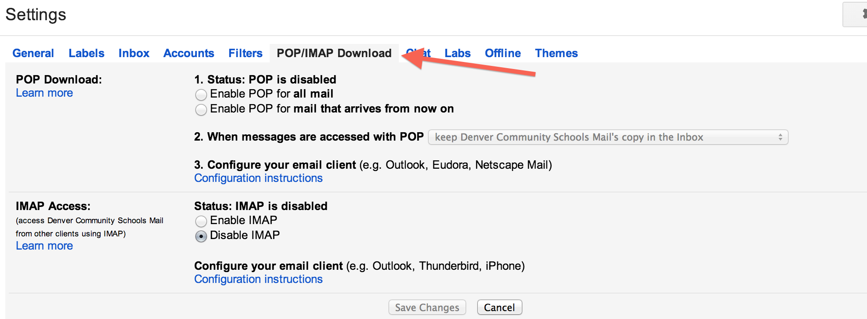
IMAP Access - ENABLE (This will be for the Mail.app and for phone use)
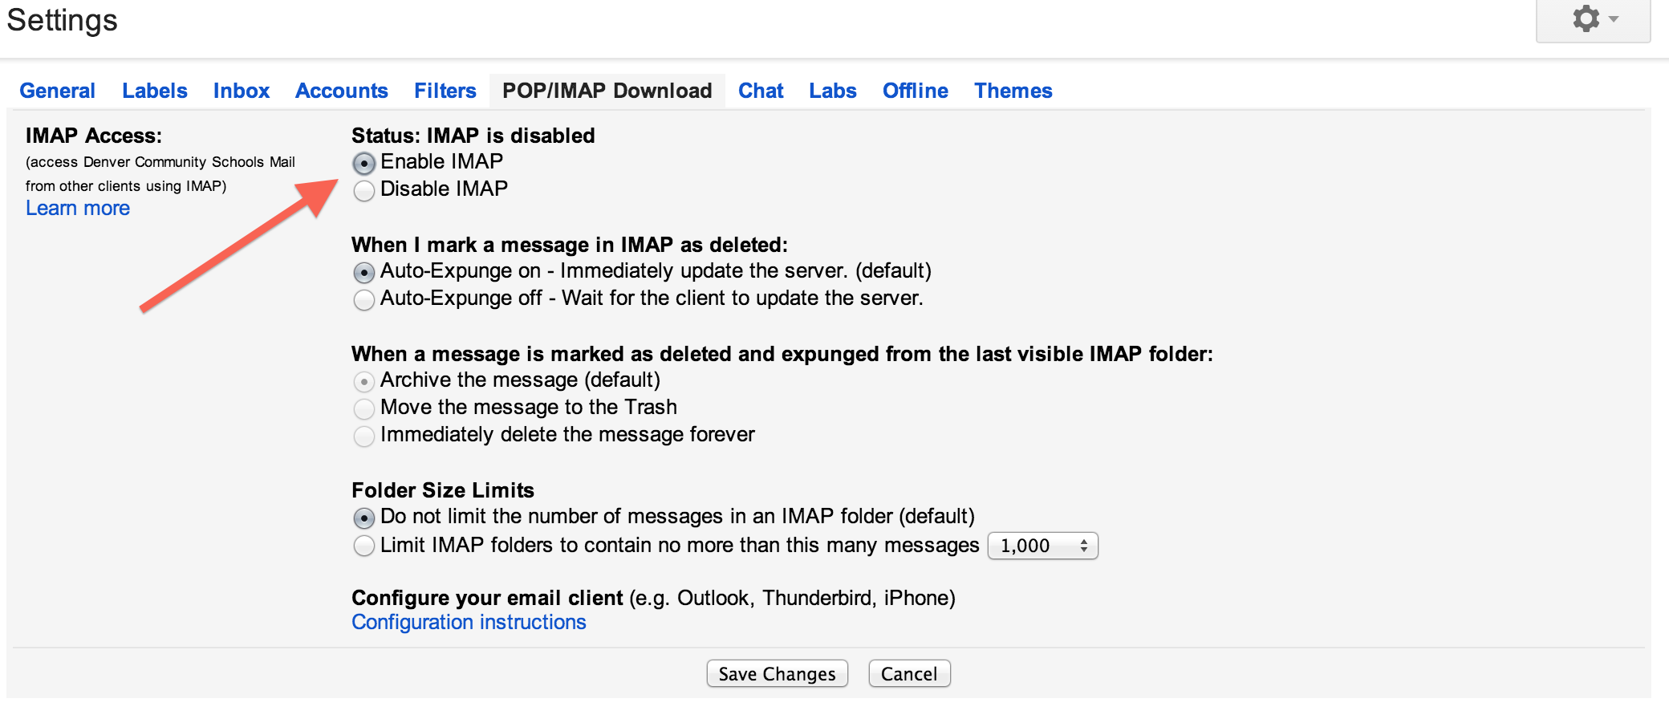
If you need to find instructions on getting your email setup on another machine or email client, look for this link…..
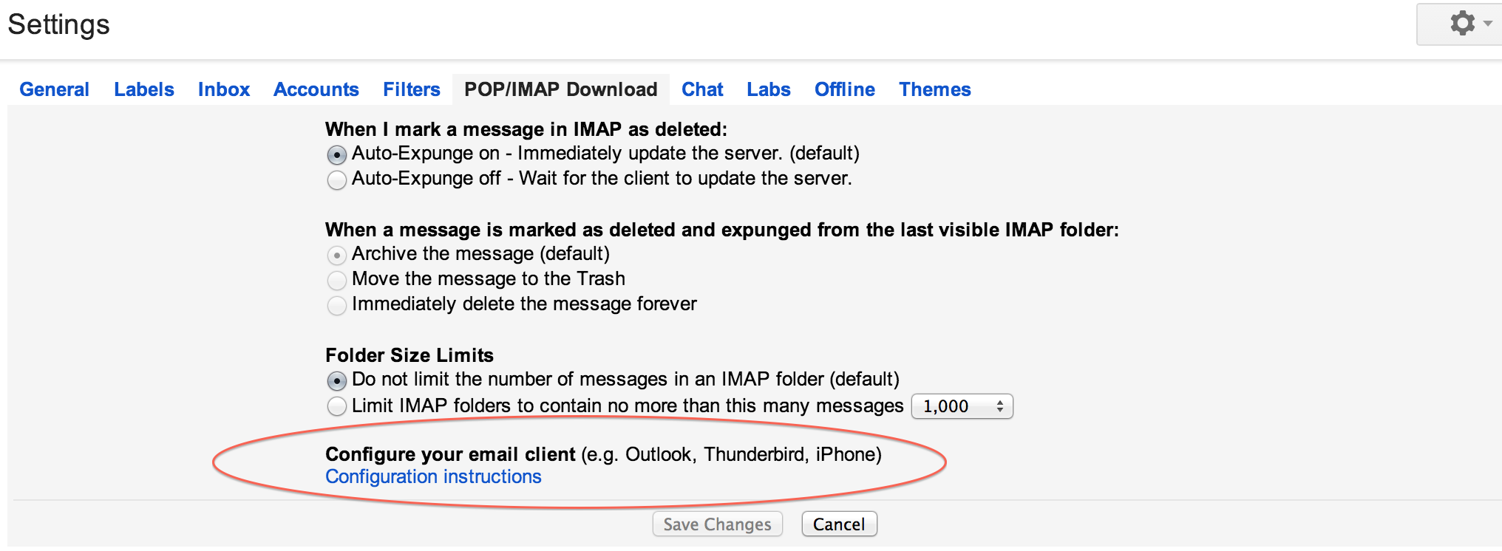

Go to the Postage Stamp Application Mail app….
(If you see a prompt to add an account when you open Apple Mail, skip to step 5:)
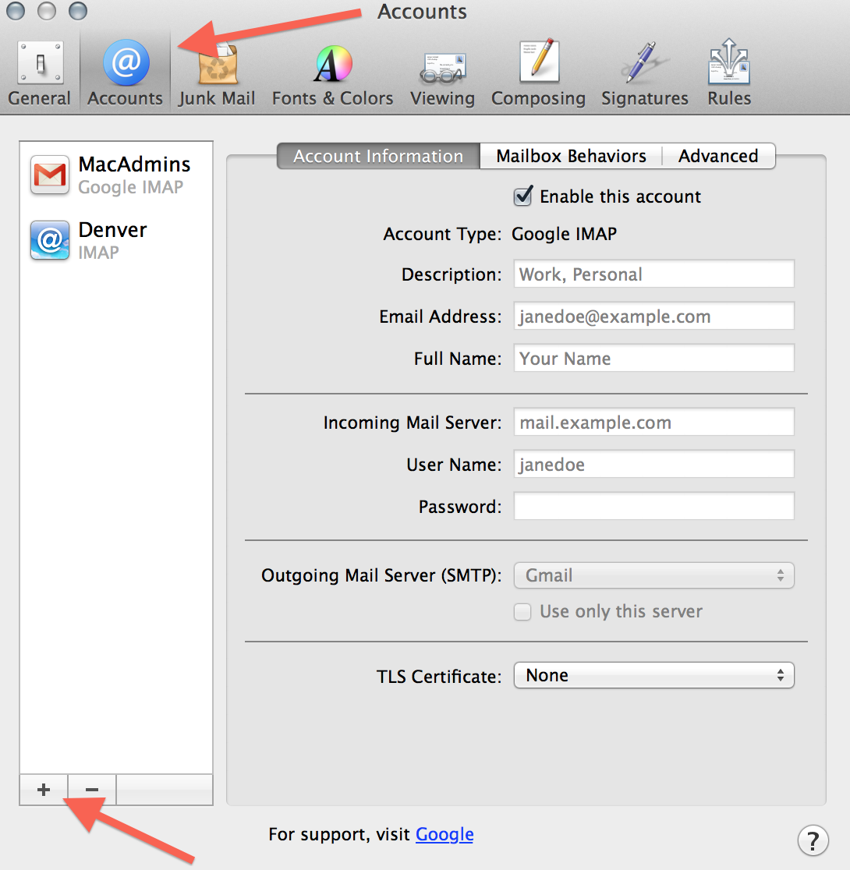
- Open the Mail app on your computer.
- Select the Mail menu at the top, and then Preferences.
- Open the Accounts section.
- Click the + button in the bottom corner.
- Choose Google.
- Type your name.
- Type your full email address
  - Students = FMLastname##@denver.k12.ia.us (## = Grad year)
  - Staff = FLastname@denver.k12.ia.us
- Type your password.
- Click Set up.
- Make sure Mail is selected and click Done.

- Incoming Mail (IMAP) Server - Requires SSL
  - imap.gmail.com
  - Port: 993
  - Requires SSL:Yes
- Outgoing Mail (SMTP) Server - Requires TLS
  - smtp.gmail.com
  - Port: 465 or 587
  - Requires SSL: Yes
  - Requires authentication: Yes
  - Use same settings as incoming mail server
- Full Name or Display Name: [your name]
- Account Name or User Name: your full Gmail address (username@denver.k12.ia.us).
- Email address: your full Gmail address (username@denver.k12.ia.us)
- Password: your Google password

